LAB REPORT实验报告
Lab Title | C++ Templates |  |  |  | Lab No. | 14
Stud. Name | Jiang Yunxiang | Major | CST |  | Class
Student ID | 2022102330 |  | Date | 5/26
Lab description/objectives:
Create the C++ Function Template named sumMultiPowers() so that it has three parameters sum, x, and n. The first two parameters will have the type represented by the function template type parameter T. n will always be int. The return type is void. All parameters are passed by value except for sum which is passed by reference. A Template Function created from sumMultiPowers() will compute
sum = 1 + x + 2x^2 + 3x^3 + ... + nx^n

Source code:
（Paste the source code here）
#include<iostream>
using namespace std;
template <typename t>

void sumMutiPowers(t &sum, t x, int n)
{
sum = 1;
for (int i = 0; i <= n; i++)
{
sum = sum + i * pow(x, i);
}
}
int main()
{
int sum;
sumMutiPowers(sum, 2, 3);
cout << "sum = " << sum << endl;
float sum1;
sumMutiPowers(sum1,(float)1.5, 3);
cout << "sum1 = " << sum1 << endl;
double sum2;
sumMutiPowers(sum2, 2.2, 3);
cout << "sum2 = " << sum2 << endl;

system("pause");
return 0;
}
Program outputs:
（Paste the screenshot of program output here）
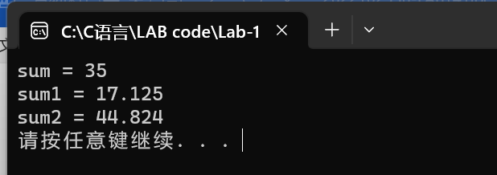
Discussion:
1．Most difficult parts
（What were the most difficult parts of your program to implement?）
Nope
2．Bugs and/or Errors
(List all the program bugs/errors you encountered and how you corrected them.)
Nope

